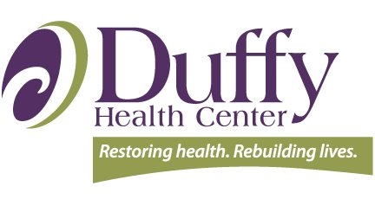
DEI-B Workplan Domains and Success Metrics Worksheet
Circle or star 1-2 goal(s) or metric(s) you plan to work on when you return!

These are the domains in Duffy Health Center’s DEI-B workplan. Your organization may have grouped them differently!

Workplan Domain | Workplan Goal  (Behavior or State That is Changing) | Metric to Measure Change
Physical environment

Clinical care
Policies
Workforce and Board
Mentoring
Language
Sustainability
DEI-B Collaborative structure
Community engagement

