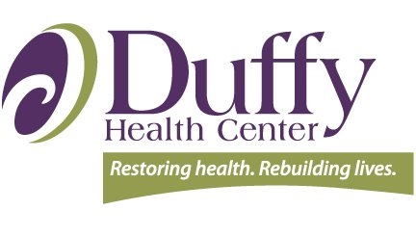
“Building DEI-B from the Ground Up” Resources List

Organizational Assessments
- Health Outreach Partners "Inclusion Scorecard for Population Health”: https://outreach-partners.org/2023/12/assessing-for-diversity-equity-and-inclusion-the-inclusion-scorecard-for-population-health-a-coffee-break-webinar/
  - Fill out contact information to set up a demo meeting and then receive scorecard.
- Institute for Healthcare Improvement “Improving Health Equity Assessment”: https://www.ihi.org/sites/default/files/IHI_ImprovingHealthEquity_AssessmentTool.pdf
- NAATP “All-Staff DEIB Stages of Change Assessment: https://online.fliphtml5.com/xqpok/dyrr/#p=5
- Brandeis University “DEI Organizational Assessment Guide”: https://heller.brandeis.edu/iere/pdfs/dei-organizational-assessment-tools.pdf
  - Contains assessments for different types of organizations.

Change Management and Adaptive Leadership
- University of California Berkeley toolkits: https://hr.berkeley.edu/grow/grow-your-resources/helpful-toolkits-and-guides
- Adaptive Leadership in 12 Minutes: v https://www.youtube.com/watch?v=9kVxxfknua4 (Dr. Ronald Heifetz)
- Productive Zone of Disequilibrium: https://vimeo.com/579931706 (Seth Kahan)
- Adaptive vs. Technical Problems: https://www.youtube.com/watch?v=UwWylIUIvmo (Dr. Ronald Heifetz)

NHCHC Materials
- NHCHC 2023 conference “Learning Lab: Developing an Organizational Justice-Equity-Diversity-Inclusion (JEDI) Language”: https://nhchc.org/resource/learning-lab-developing-an-organizational-justice-equity-diversity-inclusion-jedi-language/
  - LOTS of resources here!
- Online courses: https://nhchc.org/online-courses/ (JEDI category)
- Webinars: https://nhchc.org/webinars/ (JEDI category

