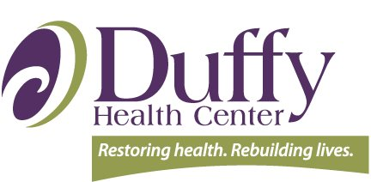
One word that describes DEI-B at my organization:

Brief DEI-B Organizational Assessment

Instructions: Prior to the start of the workshop, please assess your organization’s current DEI-B status. Add up the numbers associated with your answer. Knowing the current status of your organization’s DEI-B efforts will help to inform the discussion at your table throughout the workshop.

- My organization reviews patient satisfaction survey data by demographic categories (e.g., gender, race, ethnicity, primary language, LGBTQIA+).

- My organization has not included this in our current work (1).
- My organization is talking about this topic (2).
- My organization has an initial process in place for this topic with room to grow (3).
- My organization does this well with a robust and sustainable process in place (4).

- My organization performs an analysis of exit interviews by department and demographic group.

- My organization has not included this in our current work (1).
- My organization is talking about this topic (2).
- My organization has an initial process in place for this topic with room to grow (3).
- My organization does this well with a robust and sustainable process in place (4).

- My organization uses symbols and non-language dependent signage to direct health center visitors.

- My organization has not included this in our current work (1).
- My organization is talking about this topic (2).
- My organization has an initial process in place for this topic with room to grow (3).
- My organization does this well with a robust and sustainable process in place (4).

- Leadership has established community outreach efforts to engage with vulnerable patient populations. (This may take the form of meeting with leadership from community organizations, attending health-related information forums or special events.)

- My organization has not included this in our current work (1).
- My organization is talking about this topic (2).
- My organization has an initial process in place for this topic with room to grow (3).
- My organization does this well with a robust and sustainable process in place (4).
My organization’s score:
Score interpretation:
4 = not yet starting but interested. 5-10 = initial development. 10-15 = developing. 16 = mature DEI-B efforts.

