Introduction
People experiencing homelessness (PEH) often seek services within the emergency department (ED), both due to acute health care issues and complex barriers to accessing community based medical care. PEH have competing daily needs that are time consuming, like getting in lines for shelter and food, that often take precedence over routine medical care. This causes individuals with chronic conditions to wait until there is a crisis before seeking care. The emergency department is often a reflection of all the holes in our social safety net and the needs of clients are a mismatch with the services that are offered within the ED. This mismatch causes significant strain on ED capacity and staff frustration. Many clients report feeling stigmatized, that ED visits are often traumatic, and that their needs are not met. Connecting clients to services that provide tailored and holistic care will support both EDs and PEH, improving outcomes for patients and the capacity of EDs to treat individuals with life threatening illness or injury. Health Care for the Homeless (HCH) health centers and medical respite programs are uniquely equipped to address the multiple complex needs of people experiencing homelessness. Building partnerships among EDs, health centers, and social service organizations can mitigate barriers to adequate health care and address both the immediate and long-term needs of unhoused individuals in their communities.

This guide provides an overview of resources and best practices that can be implemented by communities to improve the continuum of health care for people experiencing homelessness.

Factors Influencing Health
People experiencing homelessness:
- Face significant health disparities and lack of access to routine health care services, despite being more likely to experience multiple chronic health conditions (Baggett et al. 2010; NHCHC, 2019).
- Utilize the ED at higher rates than the general population, are more likely to be admitted to the hospital, and have prolonged hospital stays (Schappert et al., 2020; Feigal et al., 2014; Wadhera et al., 2019).
- Have higher rates of mental health, traumatic brain injury, and substance use disorders than the general population (Stubbs et al., 2019).
- Have higher rates of geriatric and physical health conditions 20–30 years earlier than their housed counterparts (Fazel et al., 2014; NHCHC, 2019).
- Have a higher prevalence of trauma and post-traumatic stress disorder (Ayano et al., 2020).
Many PEH report having encountered discrimination or trauma in health care settings (LeBrun-Harris et al., 2013, Magwood et al., 2019). The combination of multiple chronic conditions, delayed access to medical care, and concerns of discrimination in health care settings often results in individuals waiting until a condition is emergent before seeking care, and thus often seeking medical care within the emergency department. Higher risks for assault and weather-related injuries also increase the need for people experiencing homelessness to seek ED care (NHCHC, 2007; Meinbresse et al., 2014).

Approaches to Care
Harm Reduction
- Harm reduction is a set of practices that aim to reduce potential negative consequences associated with drug use (Harm Reduction Coalition, 2022). A harm reduction approach centers the rights of people who use drugs to receive needed health services. It supports people to make their own decisions around substance use and provides practical strategies and ideas to increase safety and reduce harm.
- PEH face multiple barriers to accessing routine and emergency care, including stigma around homelessness and substance use. A harm reduction approach is vital for reducing stigma and allowing people to share their health history, concerns, and goals with providers without fear of negative repercussions.
- A trauma-informed approach goes hand-in-hand with harm reduction. Trauma informed care recognizes the impact and manifestations of past or ongoing trauma, actively avoids re-traumatization, and supports patient-directed paths towards a wide spectrum of recovery.
- It is important to recognize that maintaining opioid tolerance during ED and inpatient treatment is a life-saving, harm reduction-based intervention that reduces overdose risk after discharge.
- Harm reduction practices in the Emergency Department may include:
  - Routinely including current and past substance use as part of health history in a way that is stigma reducing, e.g. included with other health history rather than as a separate inquiry.
  - Asking all patients directly about the need for withdrawal management as part of emergency department care.
  - Including order sets or protocols for managing substance use and withdrawal that are linked to substance use diagnoses in the electronic medical record.
- Harm Reduction Resources:
  - Harm Reduction Coalition
  - Substance Abuse and Mental Health Services Administration

Resources and Partnerships
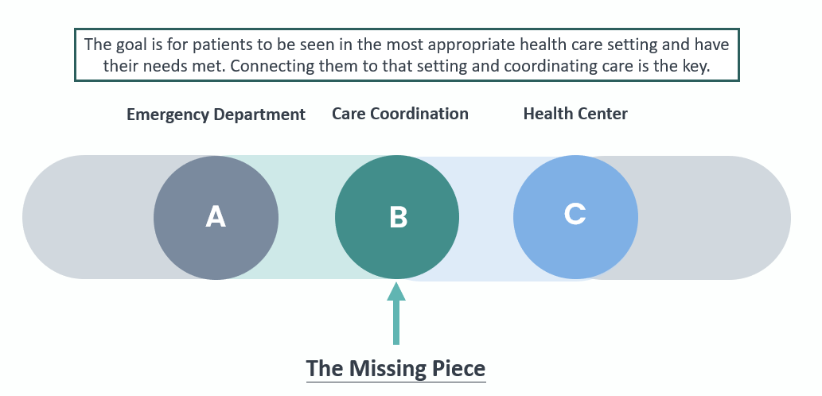

Health Centers
- Health centers provide integrated primary care and behavioral health for people regardless of insurance status or their ability to pay. Many health centers have same day appointments.
- Health Care for the Homeless health centers specialize in the unique needs of people experiencing homelessness, including complex chronic health conditions, substance use disorders, and severe persistent mental health diagnoses. The HCH program directory can be utilized by EDs to coordinate care for patients who have not yet established primary care.
- HCH programs often have outreach teams that include social service staff who can provide care coordination and wrap-around supports. These teams can be composed of a variety of staff, including Social Workers, Peer Support Specialists, Community Health Workers, or Case Managers. Whether it is accompanying a patient during an ED visit to decrease self-discharge or picking up a patient from the ED to bring them to the health center to facilitate the first appointment, outreach workers can be incredibly impactful bridge builders between EDs, patients, and health centers.
- Across the country there are EDs and Health Centers working to develop partnerships. These models vary widely. Here are some examples:
  - HCH staff provide direct outreach to EDs for PEH
  - ED Social Service staff coordinate follow-up appointments and transportation for PEH to establish care in HCH health center
  - HCH clinics develop ED follow-up patient visit types for next day follow-up appointments
  - EDs hire Peer Support Specialists to be present in the ED supporting PEH
  - ED teams initiate Suboxone for people with Opioid Use Disorder and bridge them to an appointment at an HCH health center
  - Initiating warm handoff from the ED by calling the HCH clinic and scheduling a follow-up appointment.

Medical Respite Care
- Medical respite care (MRC) is acute and post-acute medical care for people experiencing homelessness who are too ill or frail to recover from a physical illness or injury on the streets but are not ill enough to remain in the hospital.
- For individuals who have poorly controlled chronic conditions like Congestive Heart Failure, Diabetes, or chronic wounds who are high utilizers of the ED, medical respite can be an impactful intervention for stabilizing a health condition and addressing social barriers to care.
- The Medical Respite Care Directory can be a helpful tool for finding a local respite program. MRC programs can be helpful partners with EDs and some programs accept patients directly from EDs. MRCs can be a helpful bridge for patients from acute care to primary care while stabilizing health conditions and decreasing repeat visits to the ED.

Additional resources:
- Webinar Series: Partnerships to Improve Care for People without Homes in Emergency Departments

Conclusion
PEH deserve high quality compassionate health care. Due to competing priorities, PEH often deprioritize health care to meet basic needs like food and shelter and have numerous barriers to accessing community-based health care. This results in high utilization of EDs and can be traumatic for PEH and stressful for ED staff. EDs are not equipped to address long term health and social needs; this is the role of primary and behavioral health care settings. HCH health centers provide a wide range of services to support PEH. Both HCH health centers and EDs are essential parts of our health care system and offer unique sets of services. Coordination between the two settings is crucial to decreasing over utilization of the ED, increasing access to health centers, and improving health outcomes.

References
Ayano, G., Solomon, M., Tsegay, L., Yohannes, K., & Abraha, M. (2020). A systematic review and meta-analysis of the prevalence of post-traumatic stress disorder among homeless people. Psychiatric Quarterly, 91, 949-963.
Baggett, T. P., O'Connell, J. J., Singer, D. E., & Rigotti, N. A. (2010). The unmet health care needs of homeless adults: A national study. American Journal of Public Health, 100, 1326-1333. https://doi.org/10.2105/AJPH.2009.180109
Fazel, S., Geddes, J. R., & Kushel, M. (2014). The health of homeless people in high-income countries: Descriptive epidemiology, health consequences, and clinical and policy recommendations. Lancet, 384(9953), 1529-1540. https://doi.org/10.1016/S0140-6736(14)61132-6 Harm Reduction Coalition. (2022). Principles of harm reduction. National Harm Reduction Coalition. https://harmreduction.org/about-us/principles-of-harm-reduction/
Feigal, J., Park, B., Bramante, C., Nordgaard, C., Menk, J., & Song, J. (2014). Homelessness and discharge delays from an urban safety net hospital. Public Health, 128(11), 1033-1035.
Kushel, M. B., Perry, S., Bangsberg, D., Clark, R., & Moss, A. R. (2002). Emergency department use among the homeless and marginally housed: results from a community-based study. American journal of public health, 92(5), 778-784.
LeBrun- Harris, L. A., Baggett, T. P., Jenkins, D. M., Sripipatana, A., Sharma, R., Hayashi, A. S., … Ngo-Metzger, Q. (2013). Health status and health care experience among homeless patients in federally supported health centers: Findings from the 2009 patient survey. Health Services Research, 48, 992-1017. https://doi.org/10.1111/1475-6773.12009
Magwood, O., Leki, V. Y., Kpade, V., Saad, A., Alkhateeb, Q., Gebremeskel, A., … Pottie, K. (2019) Common trust and personal safety issues: A systematic review on the acceptability of health and social interventions for persons with lived experience of homelessness. PLoS ONE 14(12): e0226306. https://doi.org/10.1371/journal.pone.0226306
Meinbresse, M., Brinkley-Rubinstein, L., Grassette, A., Benson, J., Hall, C., Hamilton, R., Malott, M., & Jenkins, D. (2014). Exploring the experiences of violence among individuals who are homeless using a consumer-led approach. Violence and Victims, 29(1), 122-136. https://nhchc.org/wp-content/uploads/2019/08/vv-29-1_ptr_a8_122-136.pdf
National Health Care for the Homeless Council. (2019). Homelessness and Health: What’s the Connection? https://nhchc.org/wp-content/uploads/2019/08/homelessness-and-health.pdf
National Health Care for the Homeless Council. (2007). Exposure Related Conditions: Symptoms and Prevention Strategies. https://nhchc.org/wp-content/uploads/2019/08/Dec2007HealingHands.pdf
Schappert, S. M., Santo, L., & Ashman, J. J. (2020). Quick stats: Rate of emergency department (ED) visits, by homeless status and geographic region-National Hospital Ambulatory Medical Care Survey, United States, 2015-2018. MMWR: Morbidity and mortality weekly report, 69(50), 1931-1931.
Stubbs, J.L., Thornton, A.E., Sevick, J.M., Silverberg, N.D., Barr, A.M., Honer, W.G., & Panenka, W.J. (2019). Traumatic brain injury in homeless and marginally housed individuals: A systematic review and meta-analysis. The Lancet Public Health, 5(1), e19-e32. https://doi.org/10.1016/S2468-2667(19)30188-4
Wadhera, R. K., Choi, E., Shen, C., Yeh, R. W., & Maddox, K. E. J. (2019). Trends, causes, and outcomes of hospitalizations for homeless individuals: a retrospective cohort study. Medical care, 57(1), 21.
This project is supported by the Health Resources and Services Administration (HRSA) of the U.S. Department of Health and Human Services (HHS) as part of awards totaling $2,792,647 with 0 percentage financed with non-governmental sources. The contents are those of the author(s) and do not necessarily represent the official views of, nor an endorsement, by HRSA, HHS, or the U.S. Government. For more information, please visit HRSA.gov
National Health Care for the Homeless Council (NHCHC) HRSA-funded National Training and Technical Assistance Partners (NTTAPs)

