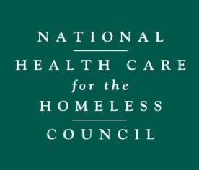
Corporate Affiliate Application

Please complete this form electronically, as some fields are drop-down options, and then print. Mail this registration form along with the check.

Please fill out the form in its entirety as the starred (*) fields are required for registration completion.

Organization Name * Click here to enter text.

Headquarters Address *
Street Address Click here to enter text. Address Line 2 Click here to enter text.
City Click here to enter text. State Click here to enter text. ZIP Code Click here to enter text.

Primary Contact Information *
Full Name Click here to enter text. Title Click here to enter text.
Email Click here to enter text. Phone Click here to enter text.

Is the primary contact listed above based elsewhere than your headquarters? *
Choose an item.

Mailing Address of Primary Contact (if different than above) *
Street Address Click here to enter text. Address Line 2 Click here to enter text.
City Click here to enter text. State Click here to enter text. ZIP Code Click here to enter text.

How did you learn about Corporate Affiliates? *
Choose an item.

If you answered “Other” (above), please specify:

Please choose a category to classify your agency: *
Choose an item.

Please provide a brief summary of your company, services, or products for use on our website. We encourage you to tailor it to the homeless health care context: *

Please acknowledge our approval policy: *
☐ I acknowledge that my Corporate Affiliate application with the National Health Care for the Homeless Council is
subject to approval by the Council’s leadership, and that Affiliation does not necessarily constitute an
endorsement by the National Health Care for the Homeless Council.

Determine your rate: *
☐ Fewer than 100 employees $3,500.00
☐ 100-500 employees $4,250.00
☐ More than 500 employees $5,000.00

Total Due: *
Choose an item.

MAILING INSTRUCTIONS

Please send a check in the amount referenced above.

Make check payable to: National Health Care for the Homeless Council

Mailing address: NHCHC
PO Box 60427
Nashville, TN 37206

Phone: (615) 226-2292

Important Note: After submitting this application and check, please email a high-resolution image of your logo to kmyatt@nhchc.org. If, for whatever reason, your application is not approved, we will reimburse your payment.

